# Software Manual

**Suggested Environment settings:**

1. CUDA: 10.0
2. cuDNN: 7.6.5
3. Python: 3.7
4. Tensorflow-gpu: 1.14.0
5. OpenCV (python): 4.2.0
6. Keras: 2.3.1

**Using the program:**

The software is developed in Windows environment, which is also suggested to run it in Windows.

Open cmd and get into the root repository, type: **python main.py**

A UI will be presented, which have five functions:

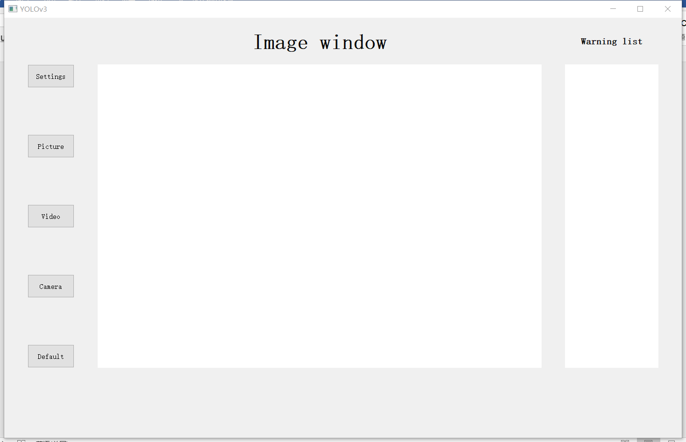

1. Setting: for this function you can set input size, IoU threshold for NMS and class score.

You can also try the new functions which are descried in the report, double NMS in bboxes filtering prcess, change form detection into tracking. These two functions are not applied in the default setting. If you want to use it, you have to tick it in the setting.

You can choose your own trained model and classes for detection by click the button, but once you choose the your own model file, you have to also choose your class file, vice versa.

Last you can choose the class you want to make warning while detecting by input the class name.

And since the alarm function can slow down the detection significantly, it is also not applied in the default settings, but you can see warning in the warning list window on the right side of the image window. if you want to try the alarm, just tick it.

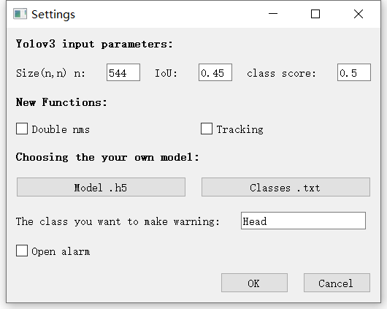

1. Picture, video, camera: for these three functions, just click the button and choose the image, video or input the URL for step and you can see the detection in the main window.

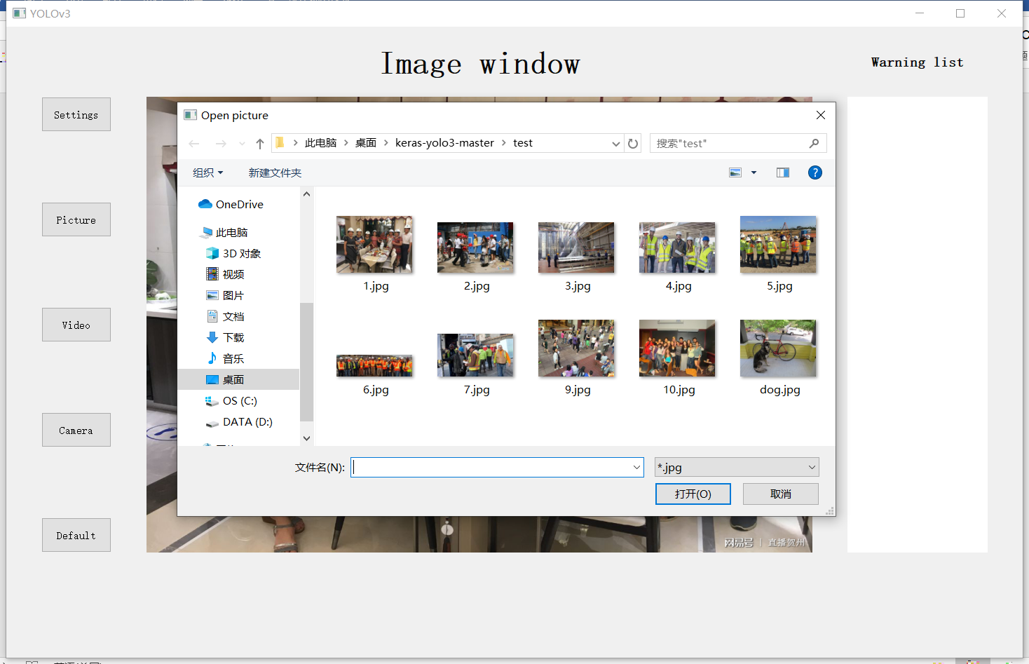

1. The last default button is used to set all the setting back to original, incase you forget want you have set.